Financial Lit Name: _______________________

______________ _____________

WS Assessment

Target 2:

STOCK transaction

**I can:**

* Calculate simple moving average and graph.
* Understand stock market ticker and total value of trade from ticker
* Learn the basic of transaction: buy and sell.

**Unit 1 Math Topics:**

* Fractions, decimals and percent
* Linear equation
* Literal equation
* Mean – Arithmetic average
* Percent increase, decrease
* Ratio and proportion
* Read, interpret and create bar and line graphs
* Simple moving average
* Spreadsheets and formulas

Stock market prices can fluctuate greatly from trade to trade based upon a variety of external factors. You have already seen that the high and low for a day may not necessarily be near the day’s opening or closing prices. Those differences often make it difficult to spot trends that are occurring over time. Smoothing techniques are statistical tools that allow an investor to reduce the impact of price fluctuations and to focus on patterns and trends. This technique is known as a simple moving average (SMA) by determining the arithmetic average (mean) closing price over a given period of time.



The closing prices for 10 consecutive trading days for a particular stock

are shown. Calculate the 5-day SMA and plot both the closing prices

and the averages on a graph.

Average from days 1-5 = $\frac{35.02+35.01+34.65+36.09+35.52}{5}$ = 35.218 $≈35.22$

from days 2 – 6

from days 3 – 7

from days 4 – 8

from days 5 – 9

from days 6 – 10

Show this graph on desmos for stamp



Now you do it, show me graph on desmos for stamp

Closing prices for 10 consecutive trading days were

$55, $60, $62, $48, $40, $42, $45, $46, $43, and $49.

Calculate the 5-day SMA. Plot both the closing prices and the averages on a graph.

Redo the problem using Spreadsheet

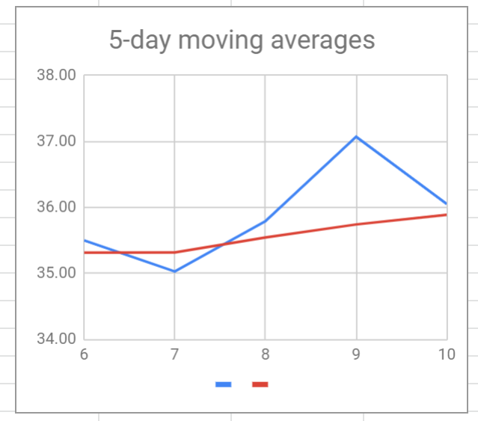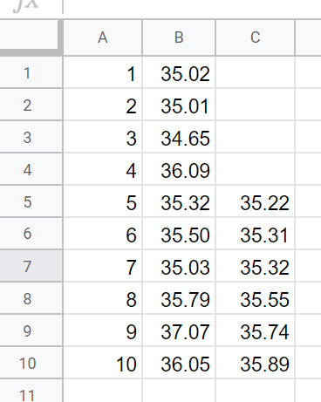

The formula in cell C5 that yields the correct average is

= sum(B1:B5)/5

The formula in cell C6 is = sum(B2:B6)/10.

Show me the spreadsheet and graph for stamp

<http://bit.ly/30ZlZLC>

Now you do it, show me graph on spreadsheet for stamp

Closing prices for 10 consecutive trading days were

$55, $60, $62, $48, $40, $42, $45, $46, $43, and $49.

Calculate the 5-day SMA. Plot both the closing prices and the averages on a graph.

**Stock Symbol** or **Ticker Symbol** The letter or letters used to identify a corporation whose shares are traded on a stock market are stock symbols or ticker symbols. Stocks that trade on the New York

Stock Exchange have 1-, 2-, or 3-letter symbols.

Google ticker symbol of stocks that have 1, 2, 3 and 4 letter. At least five each.

The trading **volume** is the number of shares traded in a single transaction. Trading volumes are listed on the ticker using a shorthand information system. The trading **price** per share may be displayed on the ticker preceded by the @ symbol. **Directional Arrows** indicate whether the traded price of a single share is greater or less than the previous day.



What can you tell form this information

4

You write a shorthand information for Amazon stock today: _________________________

Laura is interested in trades of Microsoft (MSFT). She has been following the upticks and downticks for the past two days. She knows that MSFT closed on Tuesday at $20.68, with a high at $21.25 and a low at $20.50. There were 11,902,000 shares traded on that day. She found that Monday’s closing price was $21.23. The high was $21.30 and the low was $19.95. The volume for Monday was 16,537,000 shares. Was the net money flow from Monday to Tuesday positive or negative? Hint: Average

A **portfolio** is a grouping of all the stocks a person currently owns. A portfolio changes whenever stocks are bought or sold. Stocks are best for long-term goals as over time good stocks tend to grow and become more valuable. There are many reasons that stockholders buy or sell shares. Stocks can go up or down in value. Because some stocks do not perform as planned, it is best to have a diversified portfolio of stocks of different-sized companies in different industries.

Allison bought 300 shares in stock in early 2007 for $68.24 per share. She sold them later that year for $85.89 per share. What was her capital gain? express her gain a percent of the purchase price.

You don’t buy stock at a store. Shares of stock can only be purchased through a licensed stockbroker. If you decided to sell your shares, you couldn’t bring them to school and sell them to someone in the cafeteria. You also cannot walk into a stock exchange to sell your shares. Only stockbrokers buy and sell stocks. They also give advice to investors. For their services, stockbrokers charge a **broker fee**.

Lee made two trades through his online discount broker, We-Trade. We-Trade charges a fee of $12 per trade. Lee’s first purchase was for $3,456 and his second purchase, later in the day, was for $2,000. How much did he spend on the day’s purchases, including broker fees?

Johan purchased stock six years ago for x dollars and paid a 2% broker fee. He sold that stock yesterday for y dollars and paid a discount broker $35 for the sale. Express his net proceeds algebraically.

Yolanda purchased stock for $7,000 and paid a 1.5% broker fee. She sold it for $6,325 and paid a 0.5% broker fee. Compute her net proceeds.

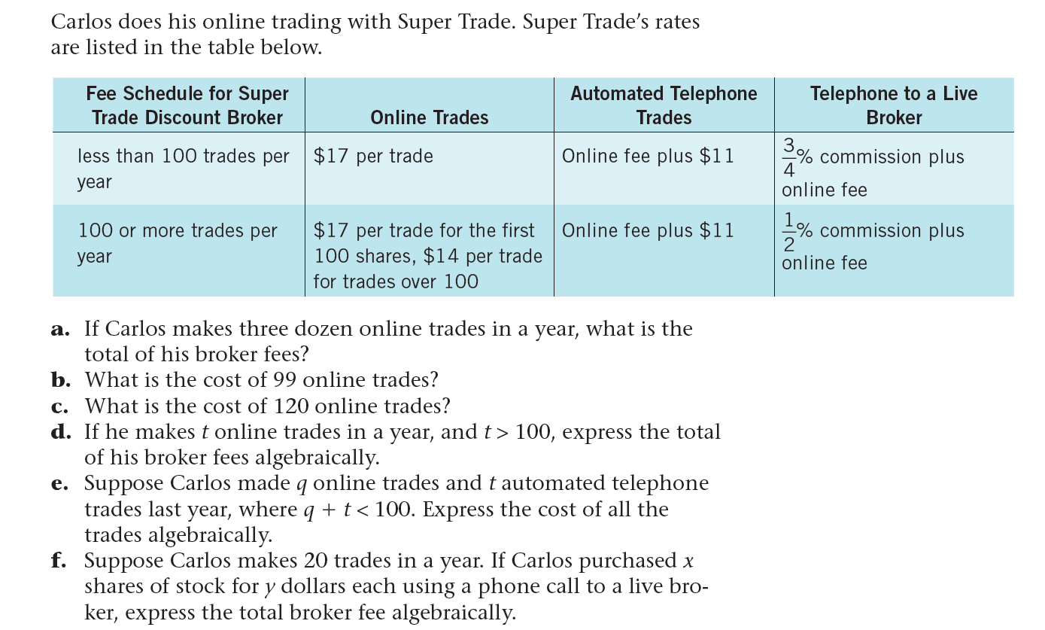



Base on those tickers, write more info about these companies

How many shares of Hewlett-Packard ware sold? _____________________

What was the total value of all the Chervon shares sold? ________________

Reggie sold the 1255 shares of Exxon-Mobil and his broker charged him 1.5% commission. How much money did the broker receive?

**Assessment Target 2**

**I can…** calculate a stock SMA and understand basic stock transaction

Determine the 3-day SMA for the ten consecutive day closing prices of Sprint Nextel Corp listed below

$7.78, $8.08, $7.99, $8.02, $7.89, $8.72, $9.19, $9.16, $8.98, $9.38

Sketch the graph and show me for stamp (both ways desmos and spreadsheet)

Use the following ticker to answer



What was the value of the Procter & Gamble Co trade?

What was the total value of all the Disney’s shares Sarah?

What was the previous day’s closing price for each stock?

a. Procter & Gamble Co __________ b. Bank of America Corp __________

c. Walt Disney Co __________ d. Kellogg Co __________

Darlene purchases $20,000 worth of stock on her broker’s advice and pays her broker a 1.5% broker fee. She sells her stock when it increases to $28,600 two years later, and uses a discount broker who

charges $21 per trade. Compute Darlene's net proceeds after the broker fees are taken out.

Lenny bought x shares of stock for $y per share last month. He paid his broker a fl at fee of $20. He sold the stock this month for $p per share, and paid his broker a 2% commission. Express Lenny's net

proceeds algebraically.

Ahmad sold 125 shares of stock for x dollars that he had purchased for $32.75 per share.

a. How much did he originally pay for the shares of stock?

b. Write an inequality that represents an amount such that Ahmad made money from the sale of the stocks of 1% broker fee.

c. Suppose Ahmad lost money on the stocks. Write an inequality that represents an amount such that Ahmad lost no more than $1,000 from the sale of the stocks.